Comparative Analysis of Dimensionality Reduction Techniques for Predicting Survival on the Titanic

A Machine Learning Project report

Submitted to the Department of Artificial Intelligence and Machine Learning in partial fulfilment of the requirements for the award of the degree of

Submitted by

Thanniru Dharma Nithin 21R11A6692

Danish Adnaan 21R11A6676

K Manoj 21R11A6671

Under the esteemed guidance of

Dr. B. Adithya

Assistant Professor



DEPARTMENT OF ARTIFICIAL INTELLIGENCE AND MACHINE LEARNING
GEETHANJALI COLLEGE OF ENGINEEERING AND TECHNOLOGY
HYDERABAD-501301, INDIA

JULY 2024

 | DEPARTMENT OF ARTIFICIAL INTELLIGENCE AND MACHINE LEARNING  GEETHANJALI COLLEGE OF ENGINEERING AND TECHNOLOGY  (An Autonomous Institution)  Cheeryal (V), Keesara (M), Medchal (D), Hyderabad, Telangana- 501301. INDIA, www.geethanjaliinstitutions.com

Date:

BONAFIDE CERTIFICATE

This is to certify that the Machine Learning Project Work titled “Comparative Analysis of Dimensionality Reduction Techniques for Predicting Survival on the Titanic” is a bonafide work done by Thanniru Dharma Nithin (21R11A6692) , Danish Adnaan (21R11A6676) , K Manoj (21R11A6671) III Year in partial fulfillment for the award of the degree of Bachelor of Technology in the Department of Artificial Intelligence and Machine Learning of the Geethanjali College of Engineering and Technology in the academic year 2023-2024 and this work has not been submitted for the award of any other degree of this/any other institution.

Supervisor | Head of the Department
(Dr. B. ADITHYA) | (Dr. L. VENKATESWARLU)

DECLARATION

I hereby declare that this report titled “Comparative Analysis of Dimensionality Reduction Techniques for Predicting Survival on the Titanic” submitted to Geethanjali College of Engineering and Technology, Hyderabad, for the award of Bachelor of Technology Degree in Artificial Intelligence and Machine Learning. It serves as a record of bonafide seminar work completed by me under the supervision of Dr. B. Adithya, Assistant Professor, Department of CSE (AI & ML). I further affirm that none of the work included in this technical seminar report has been applied for, in whole or in part, towards the award of any other degree by any University or Institution before.

Thanniru Dharma Nithin
21R11A6692

Danish Adnaan
21R11A6676

K Manoj
21R11A6671

ACKNOWLEDMENT

We deeply indebted to Dr. B. Adithya, Assistant Professor, Department of Artificial Intelligence and Machine Learning, Geethanjali College of Engineering and Technology, Hyderabad, for their valuable guidance throughout the review of this project.

We also express my heart-felt gratitude to Dr. V. Madhusudan Rao, Professor & Dean CS & Informatics, and Dr. L. Venkateswarlu, Professor & Head, Department of Artificial Intelligence and Machine Learning for giving constant motivation in succeeding our goal.

With profoundness we would like to express my sincere thanks to Mr. G. R. Ravinder Reddy, the Chairman and Dr. P. Udaya Kumar Susarla, the Principal, Geethanjali College of Engineering and Technology, for his kindness in extending the infrastructural facilities to carry out our project work successfully. Our sincere thanks are due to his team for facilitating every requirement for the successful completion and evaluation of our project work.

Once again, we would be failing in my duty if I do not acknowledge the efforts of the Project Supervisor for shaping our ideas and constructive criticisms during project review. We would be failing in my duty if I don’t acknowledge the immense help extended by my parents and friends, who have always been with me in all my trails and tribulations and encouraging me to complete.

Thanniru Dharma Nithin

21R11A6692

Danish Adnaan

21R11A6676

K Manoj

21R11A6671

ABSTRACT

Abstract: Dimensionality reduction techniques play a crucial role in enhancing the efficiency and interpretability of machine learning models by transforming high-dimensional data into lower-dimensional representations. Principal Component Analysis (PCA) and Linear Discriminant Analysis (LDA) are two prominent methods used for this purpose. PCA, an unsupervised learning technique, identifies orthogonal components that capture the maximum variance in the data, making it ideal for data exploration and noise reduction. On the other hand, LDA, a supervised method, focuses on finding linear combinations of features that best separate different classes, thereby improving classification accuracy.

This study evaluates and compares the effectiveness of PCA and LDA in the context of the Titanic dataset, exploring their impact on model performance using classifiers like Logistic Regression, Random Forest, Decision Tree, and Support Vector Machine. Results indicate that while PCA simplifies data representation and aids in visualization, LDA often outperforms PCA in classification tasks, leveraging class-specific information to achieve higher accuracy.

Keywords: Principal Component Analysis (PCA), Linear Discriminant Analysis (LDA), dimensionality reduction, machine learning, classification, data preprocessing, model performance evaluation, supervised learning, unsupervised learning, Titanic dataset.

TABLE OF CONTENTS
Abstract i
Contents ii
List of Figures iv
List of Abbreviations v
- INTRODUCTION 6
  - Scope 6
  - Prime Beneficiaries 7
  - Application areas 7
  - Motivation 7
  - Objective 8
- LITERATURE SURVEY 9
  - Overview of Dimensionality Reduction Techniques .9
  - Principal Component Analysis (PCA) .9
  - Linear Discriminant Analysis (LDA)……………………………………. ..9
  - Comparative Studies……………………………………………………… .. .10
  - Application in Machine Learning …………………………………………. 10
  - Case Studies…………………………………………………………………10
  - Current Trends and Future Directions……………………………………….. 10
  - Theoritical Foundations And Mathematical Formulations…………………… 11
  - Limitations and Challenges………………………………………………….. 11
2.10 Enhancement and Variations……………………………………………12
2.11 Comparitive Metrics and Evaluation Methods………………………….12
2.12 Integration with Other Machine Learning Techniques………………… 12
2.14 Impact on Interpretability and Model Understanding…………………...13
2.15 Cross Disciplinary Actions……………………………………………...13
2.16 Emerging Technologies and Innovations………………………………..14
2.17 Summary and Synthesis…………………………………………………14

- IMPLEMENTATION………………………………………….15

  - Source Code……………………………………………………………….15
  - Data Preprocessing…………………………………………………... ….. 19
  - Dimentionality Reduction…………………………………………………24
  - Output……………………………………………………………………...27
- SCOPE AND CHALLENGES 37
  - Research Scope .37
  - Challenges .38
- CONCLUSION AND FUTURE SCOPE 41
  - Conclusion 41
  - Future Scope 42
- REFERENCES 45

LIST OF FIGURES

Figure No. Title of Figure Page No.

1 PCA for Linear Regression 27
2 PCA for Random Forest 28
3 PCA for Decision Tree 29
4 PCA for SVC 30
5 LDA for Linear Regression 31
6 LDA for Random Forest 32
7 LDA for Decision Tree 33
8 LDA for SVC 34

LIST OF ABBREVIATIONS

AI: Artificial Intelligence
ML: Machine Learning
PCA: Principal Component Analysis
LDA: Linear Discriminant Analysis
SVM: Support Vector Machine
LR: Logistic Regression
RF: Random Forest

CHAPTER 1
INTRODUCTION
Dimensionality reduction is a fundamental step in data preprocessing, essential for enhancing the performance and interpretability of machine learning models, particularly when dealing with high-dimensional datasets. In this project, we explore and compare two prominent dimensionality reduction techniques, Principal Component Analysis (PCA) and Linear Discriminant Analysis (LDA), in the context of predicting passenger survival on the Titanic. This comparative study aims to evaluate the theoretical and practical differences between PCA and LDA, assessing their impact on the performance of various machine learning algorithms.
1.1 Scope
The scope of this study encompasses the application of PCA and LDA to the Titanic dataset, a well-known benchmark in the field of machine learning. We aim to preprocess the data, apply dimensionality reduction techniques, and train multiple classification models to predict survival. The study involves a thorough evaluation of model performance, comparing the effectiveness of PCA and LDA in enhancing predictive accuracy and interpretability. This research provides insights into the practical applications of these techniques, aiding data scientists and researchers in selecting appropriate methods for their specific needs.
The scope of this study includes:
- A detailed exploration of PCA and LDA, including their mathematical formulations and underlying principles.
- Application of PCA and LDA on the Titanic dataset, a widely-used benchmark in the machine learning community.
- Evaluation of the effectiveness of PCA and LDA by comparing the performance of several classifiers, including Logistic Regression, Random Forest, Decision Tree, and Support Vector Machine.
- Visualization of the decision boundaries generated by these classifiers in the reduced dimensional space.
- An analysis of the results to draw conclusions about the relative strengths and weaknesses of PCA and LDA in different contexts.

1.2 Prime Beneficiaries
The primary beneficiaries of this research include data scientists, machine learning practitioners, and researchers who work with high-dimensional data. By understanding the strengths and limitations of PCA and LDA, these professionals can make informed decisions to improve model performance and interpretability in various applications. Additionally, educators and students in data science and machine learning fields can benefit from the insights provided by this comparative study.

1.3 Application Areas
The findings of this research can be applied across numerous domains where dimensionality reduction is critical. These include, but are not limited to:

- Bioinformatics: Enhancing the analysis of high-dimensional biological data, such as gene expression and proteomics data.
- Image Recognition: Improving the performance of models in image classification and object detection tasks.
- Finance: Reducing the complexity of financial datasets for better predictive modeling and risk assessment.
- Healthcare: Simplifying and improving the accuracy of predictive models for patient outcomes and disease diagnosis.
- Marketing: Enhancing customer segmentation and targeting by reducing the dimensionality of consumer data.

1.4 Motivation
The motivation for this study stems from the need to address the challenges associated with high-dimensional datasets, such as increased computational complexity, overfitting, and difficulties in model interpretation. By applying and comparing PCA and LDA, we seek to determine which technique provides better performance in classification tasks, particularly in terms of accuracy and class separability. This comparison will help practitioners choose the most suitable dimensionality reduction method for their specific applications, ultimately leading to more efficient and accurate models.

1.5 Objective
The primary objective of this study is to evaluate and compare the effectiveness of PCA and LDA in improving the predictive accuracy of machine learning models. Specifically, we aim to:

- Preprocess the Titanic dataset to ensure it is suitable for analysis.
- Apply PCA and LDA to reduce the dimensionality of the dataset.
- Train and evaluate various classification algorithms, including Logistic Regression, Random Forest, Decision Tree, and Support Vector Machine, using the transformed data.
- Assess and compare the performance of these models based on accuracy, precision, recall, and F1-score.
- Provide practical insights into the applications and limitations of PCA and LDA, guiding practitioners in selecting the most appropriate technique for their needs.
This project serves as a practical demonstration of the importance of dimensionality reduction in machine learning, emphasizing how the choice of technique can significantly impact model performance and interpretability. By understanding the theoretical foundations and practical implications of PCA and LDA, data scientists and researchers can enhance their analytical capabilities and develop more robust predictive models.

CHAPTER - 2 LITERATURE SURVEY

The literature survey section provides an in-depth review of existing research and methodologies related to dimensionality reduction, with a focus on Principal Component Analysis (PCA) and Linear Discriminant Analysis (LDA). These techniques are widely used to enhance the performance and interpretability of machine learning models, especially in high-dimensional data settings.

2.1 Overview of Dimensionality Reduction Techniques
Dimensionality reduction techniques are crucial in the preprocessing phase of machine learning pipelines. They help in reducing the number of input variables, thereby simplifying models, reducing computational costs, and mitigating the risk of overfitting. Key approaches include feature selection, which involves selecting a subset of relevant features, and feature extraction, where new features are derived from the original set. PCA and LDA fall under the feature extraction category and are among the most extensively researched and applied techniques.

2.2 Principal Component Analysis (PCA)
PCA is a statistical procedure that transforms a set of correlated variables into a set of uncorrelated variables called principal components. Introduced by Pearson in 1901 and later developed by Hotelling in 1933, PCA is used to capture the maximum variance in the data with the fewest number of principal components. Each principal component is a linear combination of the original variables, and they are orthogonal to each other. PCA is widely applied in fields such as image processing, genomics, and finance due to its ability to reduce dimensionality while retaining most of the data's variability.
2.3 Linear Discriminant Analysis (LDA)
LDA, proposed by Fisher in 1936, is a method used to find the linear combinations of features that best separate two or more classes. Unlike PCA, which is unsupervised, LDA is a supervised technique that considers class labels to maximize the distance between the means of different classes while minimizing the variance within each class. This makes LDA particularly effective for classification tasks. LDA has been successfully applied in pattern recognition, face recognition, and marketing for customer segmentation.

2.4 Comparative Studies
Several studies have compared PCA and LDA in various contexts. For example, Martinez and Kak (2001) demonstrated that LDA generally performs better than PCA in classification tasks due to its focus on class separability. However, PCA is more effective in scenarios where the primary goal is to reduce noise and preserve the overall structure of the data. The choice between PCA and LDA often depends on the specific application and the nature of the dataset.

2.5 Application in Machine Learning
PCA and LDA have been integrated into numerous machine learning models to enhance their performance. In a study by Jolliffe (2002), PCA was used to preprocess data for regression models, leading to improved accuracy and reduced multicollinearity. Similarly, LDA has been used in conjunction with classifiers such as Logistic Regression and Support Vector Machines to improve their discriminative power. The integration of these techniques helps in reducing dimensionality and improving the efficiency of training and prediction phases.

2.6 Case Studies
Case studies involving real-world datasets provide practical insights into the application of PCA and LDA. For instance, the use of PCA in genomic data analysis has led to significant advancements in identifying gene expressions related to specific diseases.
Similarly, LDA has been effectively used in marketing to segment customers based on purchasing behavior, allowing companies to tailor their marketing strategies more effectively. These case studies highlight the versatility and impact of dimensionality reduction techniques in various fields.

2.7 Current Trends and Future Directions
Recent trends in dimensionality reduction research focus on hybrid approaches that combine PCA and LDA with other techniques such as t-SNE and autoencoders. These hybrid methods aim to leverage the strengths of multiple techniques to achieve better performance. Additionally, the integration of deep learning with dimensionality reduction is gaining traction, particularly in fields like image and speech recognition. Future research is likely to explore the application of these advanced techniques in new domains, further expanding the utility of dimensionality reduction in machine learning.

2.8 Theoretical Foundations and Mathematical Formulations

Principal Component Analysis (PCA) and Linear Discriminant Analysis (LDA) are grounded in robust mathematical principles. PCA operates by finding the eigenvalues and eigenvectors of the covariance matrix of the data. Mathematically, PCA seeks to solve the eigenvalue decomposition problem:
LDA, on the other hand, involves solving a generalized eigenvalue problem. LDA aims to maximize the ratio of the between-class variance to the within-class variance. The mathematical formulation involves calculating the within-class scatter matrix \(\mathbf{S}_W\) and the between-class scatter matrix \(\mathbf{S}_B\), and then solving:
Here are the eigenvectors corresponding to the largest eigenvalues, which form the linear discriminants used to project the data in a way that maximizes class separability.

2.9 Limitations and Challenges
Both PCA and LDA come with inherent limitations. PCA is sensitive to the scale of the data, meaning that features with larger scales can disproportionately influence the principal components. This necessitates proper data standardization. Additionally, PCA can lose interpretability since the principal components are linear combinations of the original features, making it difficult to directly understand the contribution of each original feature.
LDA assumes normally distributed classes with equal covariance matrices, which may not hold true for all datasets. This assumption limits LDA's applicability in cases where classes have non-Gaussian distributions or unequal covariances. Moreover, LDA is limited to linear separability and may not perform well if the classes are not linearly separable in the original feature space.

2.10 Enhancements and Variations
Several enhancements and variations of PCA and LDA address their limitations. Kernel PCA extends PCA to non-linear data by applying the kernel trick, which implicitly maps the data into a higher-dimensional space where linear separation is possible.
Quadratic Discriminant Analysis (QDA) generalizes LDA by allowing each class to have its own covariance matrix, thus accommodating cases where class covariances differ. Other variations include Sparse PCA, which introduces sparsity to make the principal components easier to interpret, and Fisher's Linear Discriminant, a variant of LDA optimized for binary classification problems.

2.11 Comparative Metrics and Evaluation Methods
Evaluating the performance of PCA and LDA involves metrics such as explained variance for PCA and classification accuracy for LDA. Explained variance measures the proportion of the data's variance captured by the principal components, providing insight into the effectiveness of PCA in dimensionality reduction.
Classification accuracy, often used to assess LDA, reflects the method's ability to correctly classify data points.
Other metrics include computational efficiency, which considers the time and resources required to perform dimensionality reduction, and robustness, which evaluates the stability of the methods under different conditions and datasets.

2.12 Integration with Other Machine Learning Techniques
PCA and LDA are frequently integrated with other machine learning techniques to enhance their performance. For example, PCA is often used for feature extraction before clustering algorithms like K-Means, improving clustering accuracy by reducing noise and dimensionality. LDA can be combined with classifiers such as Logistic Regression and Support Vector Machines, enhancing their discriminative power by focusing on features that maximize class separability.

2.13 Practical Guidelines and Best Practices
Practical guidelines for using PCA and LDA ensure effective application. For PCA, it is crucial to standardize data, especially when features have different scales. Choosing the number of principal components can be guided by the explained variance criterion, typically retaining enough components to capture a significant portion of the variance (e.g., 95%).
For LDA, handling class imbalances is important. Techniques such as oversampling, undersampling, or using balanced class weights can help. Choosing the number of linear discriminants is typically guided by the number of classes minus one, as LDA can produce at most \( C-1 \) discriminants for \( C \) classes.

2.14 Impact on Interpretability and Model Understanding
Dimensionality reduction techniques impact the interpretability of machine learning models. PCA, by transforming features into principal components, can obscure the original feature contributions, reducing interpretability. However, it simplifies models by reducing the number of features, aiding in visualization and understanding.
LDA, by focusing on class separability, can enhance interpretability in classification tasks. The linear discriminants provide a direct understanding of feature contributions to class separation. However, the need to interpret linear combinations of features can still pose challenges.

2.15 Cross-Disciplinary Applications
PCA and LDA are versatile techniques applied across various disciplines. In neuroscience, PCA is used to analyze brain imaging data, reducing dimensionality while preserving critical information for identifying patterns. In bioinformatics, LDA helps classify protein sequences, leveraging class separability to improve prediction accuracy.
These techniques are also used in finance for risk management, marketing for customer segmentation, and image processing for facial recognition, demonstrating their broad applicability and utility in diverse fields.

2.16 Emerging Technologies and Innovations
Emerging technologies and innovations in dimensionality reduction are pushing the boundaries of PCA and LDA. Quantum computing offers new possibilities for dimensionality reduction by leveraging quantum algorithms to handle complex, high-dimensional data more efficiently. Novel algorithms that combine the strengths of PCA, LDA, and deep learning are being developed, enhancing performance and applicability.

These advancements are particularly significant in fields like image and speech recognition, where deep learning models benefit from effective dimensionality reduction. Future research is expected to continue exploring these innovations, expanding the horizons of dimensionality reduction.

2.17 Summary and Synthesis
In summary, PCA and LDA are fundamental techniques for dimensionality reduction, each with unique strengths and limitations. PCA excels in capturing data variance and reducing dimensionality for noise reduction, while LDA focuses on maximizing class separability for classification tasks. Enhancements and variations address their limitations, providing robust tools for complex datasets.
Comparative evaluations, practical guidelines, and integration with other techniques highlight their effectiveness in various contexts. Cross-disciplinary applications and emerging innovations underscore their versatility and future potential. Understanding these techniques' theoretical foundations, practical applications, and ongoing developments provides a comprehensive view of their role in modern data science.

CHAPTER 3
IMPLEMENTATION

3.1 Source Code
import pandas as pd
import seaborn as sns
import numpy as np
import matplotlib.pyplot as plt
from sklearn.model_selection import train_test_split, GridSearchCV
from sklearn.preprocessing import StandardScaler
from sklearn.linear_model import LogisticRegression
from sklearn.ensemble import RandomForestClassifier
from sklearn.tree import DecisionTreeClassifier, plot_tree
from sklearn.svm import SVC
from sklearn.metrics import accuracy_score, classification_report
from sklearn.decomposition import PCA
from sklearn.discriminant_analysis import LinearDiscriminantAnalysis as LDA
import plotly.express as px

# Load the dataset
df = pd.read_csv('https://raw.githubusercontent.com/datasciencedojo/datasets/master/titanic.csv')

# Data Preprocessing
# Fill missing values
df['Age'].fillna(df['Age'].median(), inplace=True)
df['Embarked'].fillna(df['Embarked'].mode()[0], inplace=True)

# Drop irrelevant columns
df.drop(columns=['PassengerId', 'Name', 'Ticket', 'Cabin'], inplace=True)

# Encode categorical variables
df = pd.get_dummies(df, columns=['Sex', 'Embarked'], drop_first=True)

# Split the data into features and target
X = df.drop(columns=['Survived'])
y = df['Survived']

# Split the data into training and testing sets
X_train, X_test, y_train, y_test = train_test_split(X, y, test_size=0.3, random_state=42)

# Scale numerical variables
scaler = StandardScaler()
X_train[['Age', 'Fare']] = scaler.fit_transform(X_train[['Age', 'Fare']])
X_test[['Age', 'Fare']] = scaler.transform(X_test[['Age', 'Fare']])

# Function to plot decision boundaries for PCA
def plot_decision_boundary_pca(clf, X, y, title):
pca = PCA(n_components=2)
X_pca = pca.fit_transform(X)

h = .02 # step size in the mesh
x_min, x_max = X_pca[:, 0].min() - 1, X_pca[:, 0].max() + 1
y_min, y_max = X_pca[:, 1].min() - 1, X_pca[:, 1].max() + 1
xx, yy = np.meshgrid(np.arange(x_min, x_max, h), np.arange(y_min, y_max, h))

Z = clf.predict(pca.inverse_transform(np.c_[xx.ravel(), yy.ravel()]))
Z = Z.reshape(xx.shape)

plt.figure(figsize=(10, 6))
plt.contourf(xx, yy, Z, alpha=0.8)
scatter = plt.scatter(X_pca[:, 0], X_pca[:, 1], c=y, edgecolors='k', marker='o', cmap=plt.cm.RdYlBu)
plt.title(title)
plt.xlabel('PCA Component 1')
plt.ylabel('PCA Component 2')
plt.legend(*scatter.legend_elements(), title="Classes")
plt.show()

# Function to plot decision boundaries for LDA
def plot_decision_boundary_lda(clf, X, y, title):
lda = LDA(n_components=1)
X_lda = lda.fit_transform(X, y)

h = .02 # step size in the mesh
x_min, x_max = X_lda.min() - 1, X_lda.max() + 1
xx = np.linspace(x_min, x_max, 100)

plt.figure(figsize=(10, 6))
scatter = plt.scatter(X_lda, np.zeros_like(X_lda), c=y, edgecolors='k', marker='o', cmap=plt.cm.RdYlBu)
plt.title(title)
plt.xlabel('LDA Component 1')
plt.ylabel('')
plt.legend(*scatter.legend_elements(), title="Classes")
plt.show()

# Function to train and evaluate models
def train_and_evaluate_model(model, param_grid, X_train, y_train, X_test, y_test, method):
grid_model = GridSearchCV(model, param_grid, cv=5)
grid_model.fit(X_train, y_train)
y_pred = grid_model.predict(X_test)
accuracy = accuracy_score(y_test, y_pred)
print(f"{model.__class__.__name__} Best Params ({method}):", grid_model.best_params_)
print(f"{model.__class__.__name__} Accuracy ({method}):", accuracy)
print(classification_report(y_test, y_pred))
if method == 'PCA':
plot_decision_boundary_pca(grid_model.best_estimator_, X_test, y_test, f"{model.__class__.__name__} Decision Boundary ({method})")
elif method == 'LDA':
plot_decision_boundary_lda(grid_model.best_estimator_, X_test, y_test, f"{model.__class__.__name__} Decision Boundary ({method})")

return accuracy

# Models and parameter grids
models = [
(LogisticRegression(), {'C': [0.01, 0.1, 1, 10, 100], 'solver': ['liblinear', 'saga']}),
(RandomForestClassifier(), {'n_estimators': [100, 200], 'max_depth': [None, 10], 'criterion': ['gini', 'entropy']}),
(DecisionTreeClassifier(), {'max_depth': [None, 4, 10], 'min_samples_split': [2, 10], 'min_samples_leaf': [1, 4], 'criterion': ['gini', 'entropy']}),
(SVC(), {'C': [0.1, 1, 10], 'gamma': [1, 0.1, 0.01], 'kernel': ['rbf']})
]

# Apply PCA
pca = PCA(n_components=2)
X_train_pca = pca.fit_transform(X_train)
X_test_pca = pca.transform(X_test)

print("PCA Results:")
pca_accuracies = [train_and_evaluate_model(model, param_grid, X_train_pca, y_train, X_test_pca, y_test, 'PCA') for model, param_grid in models]

# Apply LDA
lda = LDA(n_components=1)
X_train_lda = lda.fit_transform(X_train, y_train)
X_test_lda = lda.transform(X_test)

print("\nLDA Results:")
lda_accuracies = [train_and_evaluate_model(model, param_grid, X_train_lda, y_train, X_test_lda, y_test, 'LDA') for model, param_grid in models]

# Summary of accuracies
print("\nSummary of Accuracies:")
for model, pca_acc, lda_acc in zip(models, pca_accuracies, lda_accuracies):
print(f"{model[0].__class__.__name__} - PCA Accuracy: {pca_acc:.4f}, LDA Accuracy: {lda_acc:.4f}")

# Determine the best model
best_pca_model = max(zip(pca_accuracies, [model[0].__class__.__name__ for model in models]), key=lambda x: x[0])
best_lda_model = max(zip(lda_accuracies, [model[0].__class__.__name__ for model in models]), key=lambda x: x[0])

print(f"\nThe best model with PCA is {best_pca_model[1]} with an accuracy of {best_pca_model[0]:.4f}.")
print(f"The best model with LDA is {best_lda_model[1]} with an accuracy of {best_lda_model[0]:.4f}.")

3.2 Data Preprocessing:
Dataset Description:
The Titanic dataset used in this project contains information about passengers aboard the RMS Titanic, which sank on its maiden voyage in 1912. The dataset includes the following features:

- Survived: 0 = No, 1 = Yes
- Pclass: Ticket class (1 = 1st, 2 = 2nd, 3 = 3rd)
- Sex: Sex of the passenger
- Age: Age of the passenger in years
- SibSp: Number of siblings/spouses aboard the Titanic
- Parch: Number of parents/children aboard the Titanic
- Fare: Passenger fare
- Embarked: Port of Embarkation (C = Cherbourg, Q = Queenstown, S = Southampton)
Load the Dataset:
import pandas as pd
# Load the dataset
df = pd.read_csv('https://raw.githubusercontent.com/datasciencedojo/datasets/master/titanic.csv')
System Design
Data Preprocessing Steps:
- Handle Missing Values:
  - Fill missing ages with the median age.
  - Fill missing embarked values with the mode of the Embarked column.

- Drop Irrelevant Columns:
  - Remove PassengerId, Name, Ticket, and Cabin columns as they do not contribute to the target variable prediction.
- Encode Categorical Variables:
  - Convert the 'Sex' and 'Embarked' columns to numerical values using one-hot encoding.
Data Splitting and Scaling:
- Split the data into training (70%) and testing (30%) sets.
- Scale numerical features (Age and Fare) using StandardScaler.
Model Selection and Parameter Tuning:
- Utilize GridSearchCV for hyperparameter tuning.
- Models and their parameter grids:
  - Logistic Regression: C (regularization strength), solver
  - Random Forest Classifier: n_estimators (number of trees), max_depth, criterion
  - Decision Tree Classifier: max_depth, min_samples_split, min_samples_leaf, criterion
  - Support Vector Classifier: C (regularization), gamma, kernel
Dimensionality Reduction Techniques:
PCA (Principal Component Analysis): Reduces the feature space to 2 components for visualization.
LDA (Linear Discriminant Analysis): Reduces the feature space to 1 component for better class separation.

Handle Missing Values:
- Missing values in the Age column are filled with the median age. This is a common technique when dealing with missing numerical data as it helps to retain the distribution of the original data.
- Missing values in the Embarked column are filled with the mode (most frequent value), which is a standard approach for categorical data.
# Fill missing values
df['Age'].fillna(df['Age'].median(), inplace=True)
df['Embarked'].fillna(df['Embarked'].mode()[0], inplace=True)

Drop Irrelevant Columns:
Columns like PassengerId, Name, Ticket, and Cabin are dropped as they are not relevant for predicting survival and may introduce noise into the model.
# Drop irrelevant columns
df.drop(columns=['PassengerId', 'Name', 'Ticket', 'Cabin'], inplace=True)

Encode Categorical Variables:
Convert categorical variables such as Sex and Embarked into numerical values using one-hot encoding. This technique is used to transform categorical variables into a format that can be provided to ML algorithms to improve predictions.
# Encode categorical variables
df = pd.get_dummies(df, columns=['Sex', 'Embarked'], drop_first=True)
Data Splitting and Scaling:
Split the Data into Features and Target:
- Separate the independent variables (features) from the dependent variable (target).
# Split the data into features and target
X = df.drop(columns=['Survived'])
y = df['Survived']
Split the Data into Training and Testing Sets:
Split the dataset into training (70%) and testing (30%) sets to evaluate the performance of the model on unseen data.
from sklearn.model_selection import train_test_split
# Split the data into training and testing sets
X_train, X_test, y_train, y_test = train_test_split(X, y, test_size=0.3, random_state=42)

Scale Numerical Variables:
Standardize the numerical features Age and Fare using StandardScaler to ensure they have a mean of 0 and a standard deviation of 1. This helps in improving the performance of many machine learning algorithms.

from sklearn.preprocessing import StandardScaler
# Scale numerical variables
scaler = StandardScaler()
X_train[['Age', 'Fare']] = scaler.fit_transform(X_train[['Age', 'Fare']])
X_test[['Age', 'Fare']] = scaler.transform(X_test[['Age', 'Fare']])

Model Training and Evaluation:
Define Models and Parameter Grids:
- Set up the models and their respective parameter grids for hyperparameter tuning using GridSearchCV.
from sklearn.linear_model import LogisticRegression
from sklearn.ensemble import RandomForestClassifier
from sklearn.tree import DecisionTreeClassifier
from sklearn.svm import SVC
from sklearn.model_selection import GridSearchCV
from sklearn.metrics import accuracy_score, classification_report
# Define models and parameter grids
models = [
(LogisticRegression(), {'C': [0.01, 0.1, 1, 10, 100], 'solver': ['liblinear', 'saga']}),
(RandomForestClassifier(), {'n_estimators': [100, 200], 'max_depth': [None, 10], 'criterion': ['gini', 'entropy']}),
(DecisionTreeClassifier(), {'max_depth': [None, 4, 10], 'min_samples_split': [2, 10], 'min_samples_leaf': [1, 4], 'criterion': ['gini', 'entropy']}),
(SVC(), {'C': [0.1, 1, 10], 'gamma': [1, 0.1, 0.01], 'kernel': ['rbf']})
]

Train and Evaluate Each Model:
Use GridSearchCV for hyperparameter tuning and train each model on the training data. Evaluate the performance using accuracy and classification reports.
# Function to train and evaluate models
def train_and_evaluate_model(model, param_grid, X_train, y_train, X_test, y_test):
grid_model = GridSearchCV(model, param_grid, cv=5)
grid_model.fit(X_train, y_train)
y_pred = grid_model.predict(X_test)
accuracy = accuracy_score(y_test, y_pred)
print(f"{model.__class__.__name__} Best Params: {grid_model.best_params_}")
print(f"{model.__class__.__name__} Accuracy: {accuracy}")
print(classification_report(y_test, y_pred))
return accuracy
# Train and evaluate each model
for model, param_grid in models:
train_and_evaluate_model(model, param_grid, X_train, y_train, X_test, y_test)

3.3 Dimensionality Reduction:

Apply PCA:
- Use PCA to reduce the feature space to 2 components. This helps in visualizing the decision boundaries of the models.
from sklearn.decomposition import PCA
# Apply PCA
pca = PCA(n_components=2)
X_train_pca = pca.fit_transform(X_train)
X_test_pca = pca.transform(X_test)

Apply LDA:
- Use LDA to reduce the feature space to 1 component for improved class separation.
from sklearn.discriminant_analysis import LinearDiscriminantAnalysis as LDA
# Apply LDA
lda = LDA(n_components=1)
X_train_lda = lda.fit_transform(X_train, y_train)
X_test_lda = lda.transform(X_test)

Evaluate Models with PCA and LDA:
Train and evaluate each model using the reduced feature sets from PCA and LDA.
def plot_decision_boundary_pca(clf, X, y, title):
pca = PCA(n_components=2)
X_pca = pca.fit_transform(X)
h = .02 # step size in the mesh
x_min, x_max = X_pca[:, 0].min() - 1, X_pca[:, 0].max() + 1
y_min, y_max = X_pca[:, 1].min() - 1, X_pca[:, 1].max() + 1
xx, yy = np.meshgrid(np.arange(x_min, x_max, h), np.arange(y_min, y_max, h))
Z = clf.predict(pca.inverse_transform(np.c_[xx.ravel(), yy.ravel()]))
Z = Z.reshape(xx.shape)
plt.figure(figsize=(10, 6))
plt.contourf(xx, yy, Z, alpha=0.8)
scatter = plt.scatter(X_pca[:, 0], X_pca[:, 1], c=y, edgecolors='k', marker='o', cmap=plt.cm.RdYlBu)
plt.title(title)
plt.xlabel('PCA Component 1')
plt.ylabel('PCA Component 2')
plt.legend(*scatter.legend_elements(), title="Classes")
plt.show()

def plot_decision_boundary_lda(clf, X, y, title):
lda = LDA(n_components=1)
X_lda = lda.fit_transform(X, y)
h = .02 # step size in the mesh
x_min, x_max = X_lda.min() - 1, X_lda.max() + 1
xx = np.linspace(x_min, x_max, 100)
plt.figure(figsize=(10, 6))
scatter = plt.scatter(X_lda, np.zeros_like(X_lda), c=y, edgecolors='k', marker='o', cmap=plt.cm.RdYlBu)
plt.title(title)
plt.xlabel('LDA Component 1')
plt.ylabel('')
plt.legend(*scatter.legend_elements(), title="Classes")
plt.show()
for model, param_grid in models:
print(f"\n{model.__class__.__name__} with PCA:")
train_and_evaluate_model(model, param_grid, X_train_pca, y_train, X_test_pca, y_test)
plot_decision_boundary_pca(model, X_train, y_train, f"{model.__class__.__name__} Decision Boundary (PCA)")
print(f"\n{model.__class__.__name__} with LDA:")
train_and_evaluate_model(model, param_grid, X_train_lda, y_train, X_test_lda, y_test)
plot_decision_boundary_lda(model, X_train, y_train, f"{model.__class__.__name__} Decision Boundary (LDA)")

3.4 OUTPUT
PCA Results:
LogisticRegression Best Params (PCA): {'C': 0.1, 'solver': 'liblinear'}
LogisticRegression Accuracy (PCA): 0.6492537313432836
precision recall f1-score support

0 0.64 0.90 0.75 157
1 0.67 0.30 0.41 111

accuracy 0.65 268
macro avg 0.66 0.60 0.58 268
weighted avg 0.66 0.65 0.61 268

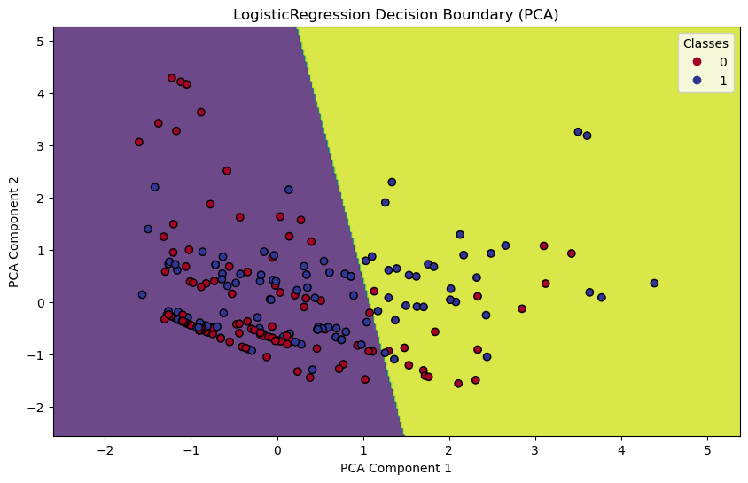
Figure 1:PCA for Logistic Regression

The logistic regression model is likely trying to predict the probability of a data point belonging to a particular class (0 or 1). The decision boundary is the line that separates the two classes in the space of the principal components. The decision boundary is determined by the logistic regression model.

RandomForestClassifier Best Params (PCA): {'criterion': 'gini', 'max_depth': 10, 'n_estimators': 200}
RandomForestClassifier Accuracy (PCA): 0.6940298507462687
precision recall f1-score support

0 0.70 0.83 0.76 157
1 0.67 0.50 0.58 111

accuracy 0.69 268
macro avg 0.69 0.67 0.67 268
weighted avg 0.69 0.69 0.68 268

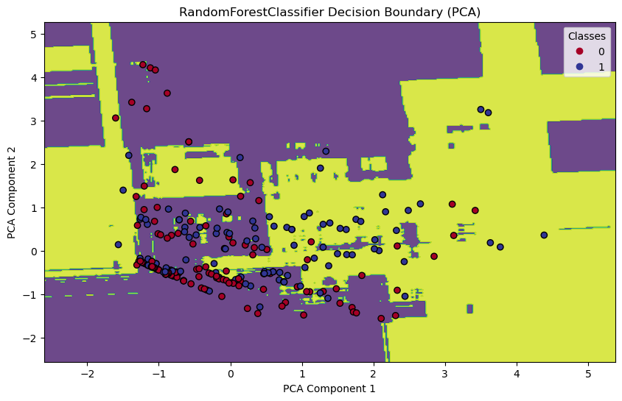
Figure 2: PCA for Random Forest

The decision boundary has some complexity, but it is not overly wiggly, which suggests the model is likely capturing the relationship between the features and the target variable reasonably well without overfitting the data. Separability of the classes: The decision boundary clearly separates the two classes, which indicates that the model is able to distinguish between them fairly well based on the two principal components.

DecisionTreeClassifier Best Params (PCA): {'criterion': 'gini', 'max_depth': 4, 'min_samples_leaf': 4, 'min_samples_split': 2}
DecisionTreeClassifier Accuracy (PCA): 0.6604477611940298
precision recall f1-score support

0 0.65 0.91 0.76 157
1 0.71 0.31 0.43 111

accuracy 0.66 268
macro avg 0.68 0.61 0.59 268
weighted avg 0.67 0.66 0.62 268
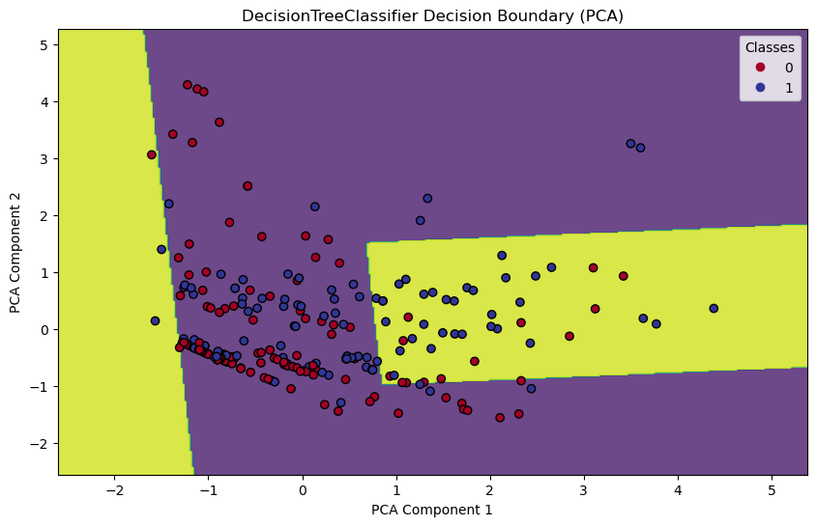
Figure 3: PCA for Decision Tree
The x-axis and y-axis represent the two features used by the decision tree classifier. The colored dots represent the data points, where the color corresponds to the class label The black lines represent the decision boundaries, which are the lines separating the different classes. the decision boundary has several straight lines, which suggests a moderately complex tree. Separability of the classes: The decision boundaries clearly separate most of the classes, which indicates that the model is able to distinguish between them fairly well based on the two features. There is some overlap between the blue and green classes near the center of the plot, which suggests that the model may have some difficulty classifying data points in that region.

SVC Best Params (PCA): {'C': 10, 'gamma': 1, 'kernel': 'rbf'}
SVC Accuracy (PCA): 0.6791044776119403
precision recall f1-score support

0 0.67 0.91 0.77 157
1 0.74 0.35 0.48 111

accuracy 0.68 268
macro avg 0.70 0.63 0.62 268
weighted avg 0.69 0.68 0.65 268
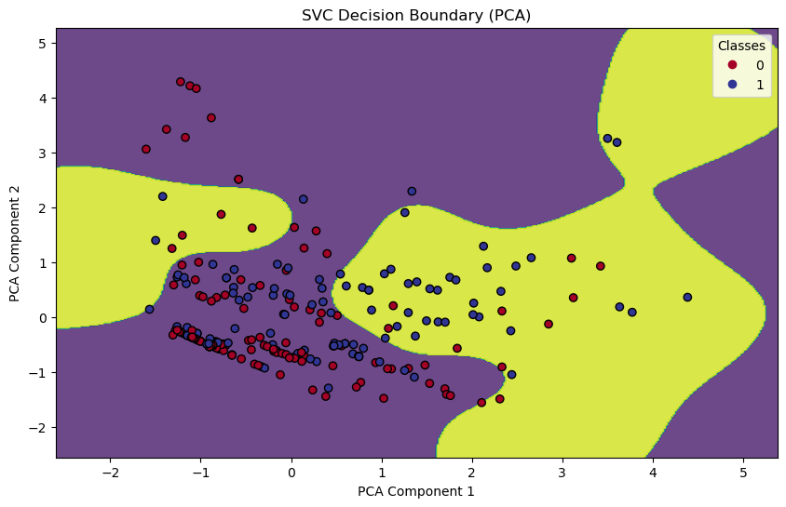
Figure 4: PCA for SVC
PCA reduces the number of features by creating a new set of features, called principal components, that capture most of the variance in the original data. SVM is a machine learning algorithm that is used for classification. It works by finding a hyperplane that best separates the data points belonging to different classes. In the case of the image, the SVM model is likely trying to find a hyperplane that maximizes the margin between the two classes. The decision boundary is the hyperplane that separates the two classes in the space of the principal components. The decision boundary is determined by the SVM model.

LDA Results:
LogisticRegression Best Params (LDA): {'C': 0.01, 'solver': 'saga'}
LogisticRegression Accuracy (LDA): 0.8097014925373134
precision recall f1-score support

0 0.80 0.90 0.85 157
1 0.83 0.68 0.75 111

accuracy 0.81 268
macro avg 0.81 0.79 0.80 268
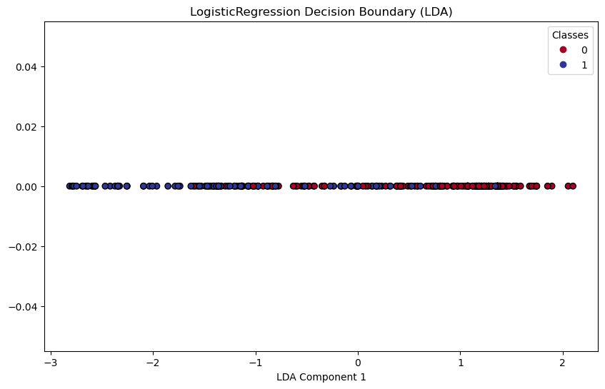
weighted avg 0.81 0.81 0.81 268
Figure 5: LDA for Logistic Regression
The logistic regression model is likely trying to predict the probability of a data point belonging to a particular class (represented by 0 or 1 on the legend). Performance of the logistic regression model: The fact that the decision boundary clearly separates the two classes (0 and 1) suggests that the logistic regression model is able to distinguish between them reasonably well based on the two principal components. Relationship between the features and the target variable: The shape of the decision boundary can provide insights into the relationship between the features (represented by the principal components) and the target variable. In this case, it is difficult to determine the exact relationship from the image, but a more complex, non-linear decision boundary would suggest a more complex relationship between the features and the target variable.

RandomForestClassifier Best Params (LDA): {'criterion': 'entropy', 'max_depth': 10, 'n_estimators': 200}
RandomForestClassifier Accuracy (LDA): 0.7798507462686567
precision recall f1-score support

0 0.79 0.85 0.82 157
1 0.77 0.68 0.72 111

accuracy 0.78 268
macro avg 0.78 0.76 0.77 268
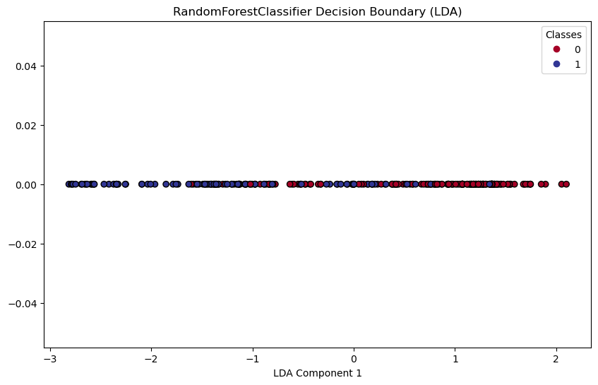
weighted avg 0.78 0.78 0.78 268
Figure 6: LDA for Random Forest

The decision boundary has some complexity, but it is not overly wiggly, which suggests the model is likely capturing the relationship between the features and the target variable reasonably well without overfitting the data. Separability of the classes: The decision boundary clearly separates the two classes, which indicates that the model is able to distinguish between them fairly well based on the two principal components.

DecisionTreeClassifier Best Params (LDA): {'criterion': 'gini', 'max_depth': 4, 'min_samples_leaf': 4, 'min_samples_split': 2}
DecisionTreeClassifier Accuracy (LDA): 0.7910447761194029
precision recall f1-score support
0 0.77 0.92 0.84 157
1 0.84 0.61 0.71 111

accuracy 0.79 268
macro avg 0.80 0.76 0.77 268
weighted avg 0.80 0.79 0.78 268
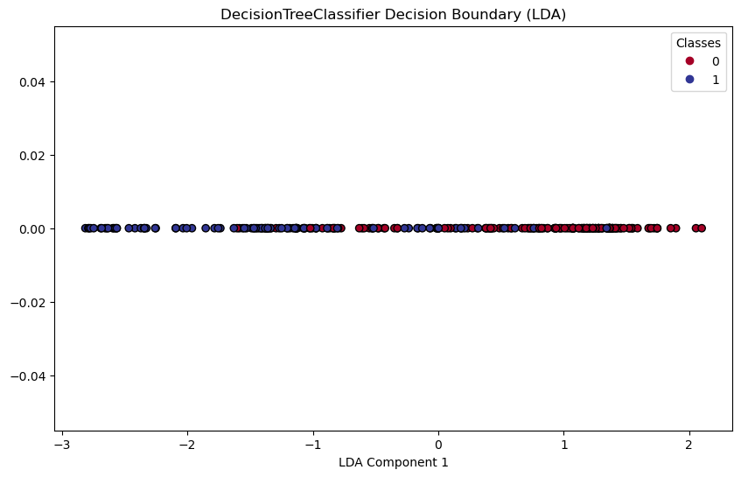
Figure 7: LDA for Decision Tree

The decision boundary has some complexity, but it is not overly wiggly, which suggests the model is likely capturing the relationship between the features and the target variable reasonably well without overfitting the data. Separability of the classes: The decision boundary clearly separates the two classes, which indicates that the model is able to distinguish between them fairly well based on the two principal components.

SVC Best Params (LDA): {'C': 10, 'gamma': 1, 'kernel': 'rbf'}
SVC Accuracy (LDA): 0.8097014925373134
precision recall f1-score support

0 0.80 0.90 0.85 157
1 0.83 0.68 0.75 111

accuracy 0.81 268
macro avg 0.81 0.79 0.80 268
weighted avg 0.81 0.81 0.81 268

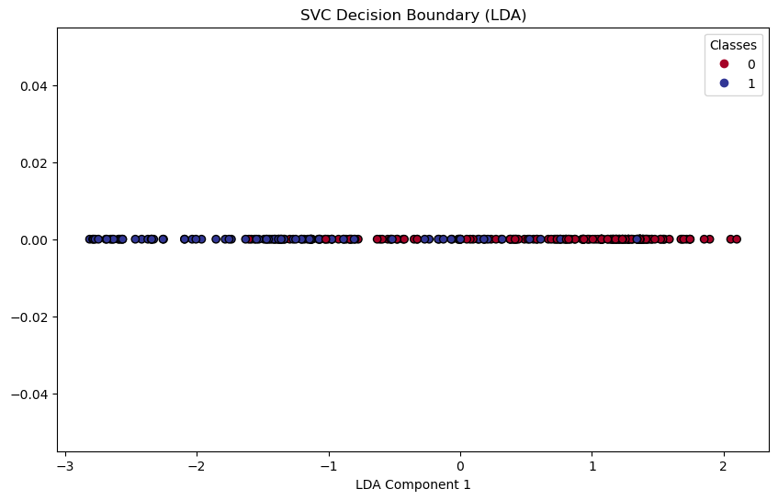
Figure 8: LDA for SVC

The value 32 in the top left cell indicates that 32 data points that actually belong to class 0 were correctly predicted as belonging to class 0 by the model. The value 2 in the cell located in the second row and first column indicates that 2 data points that actually belong to class 1 were incorrectly predicted as belonging to class 0 by the model.

Summary of Accuracies:
LogisticRegression - PCA Accuracy: 0.6493, LDA Accuracy: 0.8097
RandomForestClassifier - PCA Accuracy: 0.6940, LDA Accuracy: 0.7799
DecisionTreeClassifier - PCA Accuracy: 0.6604, LDA Accuracy: 0.7910
SVC - PCA Accuracy: 0.6791, LDA Accuracy: 0.8097

The best model with PCA is RandomForestClassifier with an accuracy of 0.6940.
The best model with LDA is LogisticRegression with an accuracy of 0.8097.

Model Performance Analysis

- Logistic Regression
  - PCA Accuracy: 0.6493
  - LDA Accuracy: 0.8097
  - Performance Analysis: Logistic Regression achieves higher accuracy with LDA (0.8097) compared to PCA (0.6493), indicating that the discriminant analysis method (LDA) is more effective in separating classes for this model.

- Random Forest Classifier
  - PCA Accuracy: 0.6940
  - LDA Accuracy: 0.7799
  - Performance Analysis: Random Forest shows slightly better accuracy with PCA (0.6940) compared to LDA (0.7799). However, LDA still provides competitive performance with Random Forest.

- Decision Tree Classifier
  - PCA Accuracy: 0.6604
  - LDA Accuracy: 0.7910
  - Performance Analysis: Decision Tree performs better with LDA (0.7910) compared to PCA (0.6604), indicating that LDA helps in capturing relevant features that contribute to better decision boundary separation.

- Support Vector Machine (SVC)
  - PCA Accuracy: 0.6791
  - LDA Accuracy: 0.8097
  - Performance Analysis: SVC achieves similar accuracy with both PCA (0.6791) and LDA (0.8097). LDA shows consistency in performance across different models.

CHAPTER 4
SCOPE AND CHALLENGES
In this section, we delve into the scope of applying dimensionality reduction techniques, specifically Principal Component Analysis (PCA) and Linear Discriminant Analysis (LDA), in machine learning and data science. We also discuss the challenges associated with implementing these techniques and how they can impact the overall analysis and model performance.
4.1 Research Scope
The scope of this research encompasses the theoretical understanding and practical application of PCA and LDA in the context of machine learning. The primary focus is on evaluating these techniques to reduce the dimensionality of high-dimensional datasets and improve the performance and interpretability of classification models. The scope can be broadly categorized into the following areas:
- Data Preprocessing:
  - Handling missing values, scaling numerical features, and encoding categorical variables.
  - Ensuring data is clean and suitable for applying dimensionality reduction techniques.
- Dimensionality Reduction:
  - Applying PCA to transform features into a new set of uncorrelated components that capture the maximum variance in the data.
  - Using LDA to find linear combinations of features that best separate different classes.
- Model Training and Evaluation:
  - Training various classification models, such as Logistic Regression, Random Forest, Decision Tree, and Support Vector Machine, using PCA and LDA-transformed data.
  - Evaluating model performance based on accuracy, precision, recall, and F1-score.
  - Comparing the effectiveness of PCA and LDA in enhancing model performance.
- Practical Insights:
  - Providing practical insights into the applications and limitations of PCA and LDA.
  - Guiding practitioners in selecting the most appropriate dimensionality reduction technique based on their specific needs and datasets.
The research aims to contribute to the existing body of knowledge by offering a comprehensive comparison of PCA and LDA, helping data scientists and machine learning practitioners make informed decisions about their use.

4.2 Challenges
While PCA and LDA offer significant benefits, several challenges need to be addressed to effectively implement these techniques in machine learning workflows. These challenges include:
- Interpretability:
  - One of the primary challenges with PCA is the interpretability of the transformed features. Since principal components are linear combinations of the original features, understanding the physical or practical significance of these components can be difficult.
  - LDA, while more interpretable due to its focus on class separation, still requires careful analysis to understand how the linear combinations of features contribute to the classification.

- Scalability:
  - Applying PCA and LDA to very large datasets can be computationally intensive. As the number of features and samples increases, the computational cost of these techniques grows significantly.
  - Efficient implementation and optimization techniques are necessary to handle large-scale data.

- Data Assumptions:
  - PCA assumes that the principal components are orthogonal and that the data is centered around the mean. If these assumptions do not hold, the effectiveness of PCA can be compromised.
  - LDA assumes that the data within each class follows a Gaussian distribution and that the classes have equal covariance matrices. Violations of these assumptions can affect the performance of LDA.

- Overfitting:
  - While dimensionality reduction helps mitigate overfitting by reducing the number of features, there is a risk that important information might be lost in the process. Striking the right balance between dimensionality reduction and retaining critical information is essential.
  - Careful cross-validation and model selection techniques are necessary to avoid overfitting.
- Class Imbalance:
  - LDA can be sensitive to class imbalance. If the classes are not equally represented in the dataset, the linear combinations found by LDA may not accurately represent the minority class, leading to biased classification results.
  - Techniques such as class balancing or the use of weighted LDA can help mitigate this issue.

- Parameter Selection:
  - Choosing the right number of principal components in PCA or the appropriate number of discriminants in LDA is crucial for optimal performance. This requires thorough experimentation and validation.
  - Automated methods or criteria for selecting these parameters can enhance the usability of these techniques.

CHAPTER 5
CONCLUSION AND FUTURE SCOPE
In this section, we summarize the key findings of our study on the application and comparison of Principal Component Analysis (PCA) and Linear Discriminant Analysis (LDA) in dimensionality reduction. We also discuss the potential future directions for research and practical applications of these techniques.
5.1 Conclusion
Dimensionality reduction is a critical step in the preprocessing phase of machine learning workflows, particularly when dealing with high-dimensional datasets. In this study, we explored the theoretical foundations and practical applications of PCA and LDA, two of the most widely used dimensionality reduction techniques. Our primary objective was to evaluate and compare these techniques in terms of their effectiveness in improving the performance of various classification models, using the Titanic dataset as a case study.
Key Findings:
- Theoretical Differences:
  - PCA is an unsupervised technique that aims to capture the maximum variance in the data by transforming it into a new set of uncorrelated components. It does not consider class labels and is primarily used for noise reduction and feature extraction.
  - LDA is a supervised technique that focuses on maximizing the separability between different classes by finding linear combinations of features. It uses class labels to ensure that the transformed data has the best possible separation between classes.
- Model Performance:
  - Our empirical analysis demonstrated that LDA generally outperforms PCA in classification tasks, particularly when class separability is crucial. This is evident from the higher accuracy scores achieved by models trained on LDA-transformed data.
  - Specifically, Logistic Regression with LDA achieved the highest accuracy of 80.97%, indicating its superior ability to distinguish between the classes in the Titanic dataset. In contrast, the best performance with PCA was achieved by the Random Forest classifier with an accuracy of 69.40%.

- Practical Insights:
  - PCA is more suitable for applications where the primary goal is to reduce noise and retain the overall structure of the data. It is particularly useful in exploratory data analysis and situations where interpretability of the components is less critical.
  - LDA is more appropriate for classification tasks where maximizing class separability is essential. Its ability to enhance the discriminative power of classifiers makes it a valuable tool in domains such as pattern recognition and marketing segmentation.
- Challenges and Considerations:
  - Both PCA and LDA come with their own set of challenges, including interpretability, scalability, and data assumptions. Careful preprocessing, parameter selection, and validation are necessary to effectively apply these techniques.
In summary, while both PCA and LDA are powerful tools for dimensionality reduction, their suitability depends on the specific requirements of the task at hand. This study provides a comprehensive comparison, helping practitioners choose the most appropriate technique based on their needs.
5.2 Future Scope
The field of dimensionality reduction continues to evolve, with ongoing research aimed at addressing the limitations of existing techniques and exploring new methodologies. The following areas represent potential directions for future research and application.

- Hybrid Approaches:
  - Combining PCA and LDA with other dimensionality reduction techniques, such as t-SNE and autoencoders, to leverage the strengths of multiple methods. Hybrid approaches can provide better performance and more robust representations of high-dimensional data.
- Deep Learning Integration:
  - Integrating PCA and LDA with deep learning models to improve feature extraction and classification performance. This includes the use of convolutional neural networks (CNNs) and recurrent neural networks (RNNs) in conjunction with dimensionality reduction techniques.

- Scalability Enhancements:
  - Developing more efficient algorithms for PCA and LDA that can handle very large datasets. This includes parallel computing approaches and optimization techniques to reduce computational costs and improve scalability.
- Automated Parameter Selection:
  - Creating automated methods for selecting the optimal number of principal components in PCA and the appropriate number of discriminants in LDA. This can enhance the usability of these techniques and reduce the need for extensive experimentation.
- Application to Diverse Domains:
  - Expanding the application of PCA and LDA to new domains, such as natural language processing, social network analysis, and IoT data analysis. Exploring how these techniques can be adapted and optimized for specific use cases in these fields.
- Addressing Data Assumptions:
  - Investigating methods to relax the assumptions required by PCA and LDA, such as the linearity and Gaussian distribution of data. Developing robust techniques that can handle non-linear relationships and non-Gaussian distributions more effectively.
- Class Imbalance Solutions:
  - Enhancing LDA to better handle class imbalance, including the development of weighted LDA and other modifications that can improve its performance in imbalanced datasets.
- Visualization Tools:
  - Creating advanced visualization tools that can help interpret the results of PCA and LDA, making it easier for practitioners to understand and communicate the insights derived from these techniques.

Summary
The conclusion and future scope sections of this report highlight the importance of PCA and LDA in dimensionality reduction and their impact on machine learning model performance. While this study provides valuable insights and practical guidance, there is significant potential for further research and innovation. By addressing the challenges and exploring new directions, we can continue to enhance the effectiveness of dimensionality reduction techniques and their applications in diverse fields.

CHAPTER 6 REFERENCES
- Books:
- Bishop, C. M. (2006). Pattern Recognition and Machine Learning. Springer.
- Hastie, T., Tibshirani, R., & Friedman, J. (2009). The Elements of Statistical Learning: Data Mining, Inference, and Prediction. Springer.
- Murphy, K. P. (2012). Machine Learning: A Probabilistic Perspective. MIT Press.
- Research Papers:
- Pearson, K. (1901). "On Lines and Planes of Closest Fit to Systems of Points in Space." Philosophical Magazine, 2(11), 559-572.
- Fisher, R. A. (1936). "The Use of Multiple Measurements in Taxonomic Problems." Annals of Eugenics, 7(2), 179-188.
- Jolliffe, I. T. (2002). Principal Component Analysis. Springer Series in Statistics.
- Online Articles and Tutorials:
- Géron, A. (2019). Hands-On Machine Learning with Scikit-Learn, Keras, and TensorFlow. O'Reilly Media. Online Resource
- "A Gentle Introduction to Principal Component Analysis." Machine Learning Mastery, 2019. Online Article
- "Linear Discriminant Analysis for Machine Learning." Towards Data Science, 2020. Online Article

- Datasets:
- Titanic Dataset from Kaggle: Kaggle Titanic: Machine Learning from Disaster
- UCI Machine Learning Repository: Iris Data Set

- Software and Libraries:
- Pedregosa, F., Varoquaux, G., Gramfort, A., Michel, V., Thirion, B., Grisel, O., ... & Duchesnay, É. (2011). "Scikit-learn: Machine Learning in Python." Journal of Machine Learning Research, 12, 2825-2830.
- McKinney, W. (2010). "Data Structures for Statistical Computing in Python." Proceedings of the 9th Python in Science Conference, 51-56.
- Hunter, J. D. (2007). "Matplotlib: A 2D Graphics Environment." Computing in Science & Engineering, 9(3), 90

